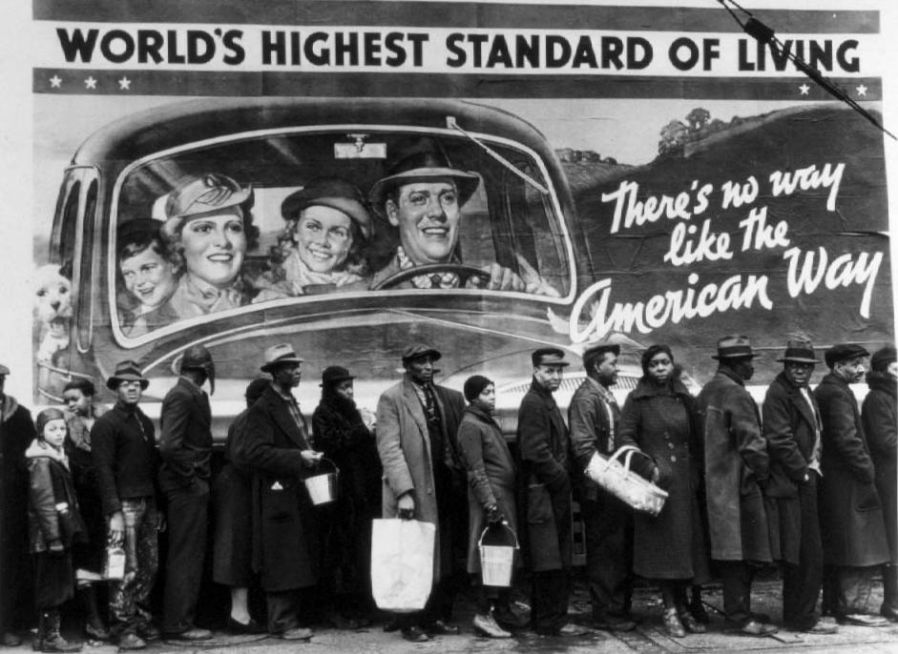
After discussing how the visual and verbal elements in this photo from 1937, make a statement about the American dream at the time of the Louisville Flood(6-8 sentences).
Briefly articulate how the picture and the language inform and imply meaning.

